Leonardo Reyes|COMP3700

HW4

The medical information management system will manage a database that is accessible by doctors, nurses, laboratory testers, and management personnel to view patient records and provide services. The system will be used to communicate information with other systems such as ones used by pharmacy, laboratory, and etc.

A new patient can be added by the management personnel on the patient’s first visit. All other personnel can view patient information, but cannot alter their information. Only the management personnel can edit patient information. Doctors and nurses will be able to add notes of patient visits, prescriptions, and lab results.

The database will hold patient information. Doctors and nurses will have a form to write on for a patient visit that can be added to patient record after the visit. The system will also handle any prescriptions that the doctor prescribes and updates the patient record when the order is processed. The pharmacy, laboratory, and radiology departments will also have access to patient records and are able to add any comments to a patients’ record, but cannot change any of the information about the patient. The management system will process information from the time the patient enters the office until the patient leaves. The database will also contain a schedule for all doctors, it will contain information on what dates and times the doctors are available to be scheduled.



Use Case



Make appointment – the patient will call the doctor’s office and talk to a receptionist to make an appointment. The receptionist will then look at the database to see what spots are available. Then after confirming with the patient, the receptionist will then schedule an appointment. After an appointment is scheduled the system will update the doctor’s schedule.

fillOutForm – this use case will have several uses because it can be done by different actors. A form will consist of different types. Patients will fill out a form the first time he/she visits the doctor’s office or if the patient needs to update their information. The doctor can fill out forms like prescribing medicine or notes for a patient visit. The receptionist can then enter any data into the system to update patient information.

Prescribe medicine – this use case is only allowed by the doctor. A doctor will decide what medicine the patient needs and fill out a form to be sent to the pharmacy. Then system will send the data to the pharmacy and update the status of the prescription when the pharmacy processes the data.

Checkup – is done by the doctor. The doctor will perform tests on the patient to gather data. The tests can include checking vital signs to drawing blood for lab test. The system will update the patient information with the data inputted by the doctor.

Checkout – after the patient is done with the doctor visit he/she will go to the receptionist for a checkout. The receptionist will calculate the charge of the visit and process that information in the system. The system will then check to see if the patient is insured and adjust any payment for the visit and tell the receptionist whether or not the patient has a balance to pay. If the patient has a balance due the receptionist can then tell the system to bill the patient later or if the patient pays upfront give options for types of payment (cash, credit card, checks) and then process the payment.

In the case of a patient scheduling an appointment, the receptionist has to check and make sure when a doctor has an open slot.

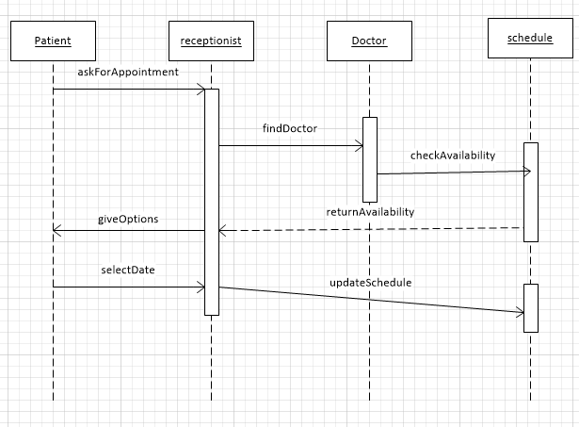

When a doctor needs to prescribe his/her patient medicine it has to send a message to the pharmacy and wait for the pharmacy to process the prescription.

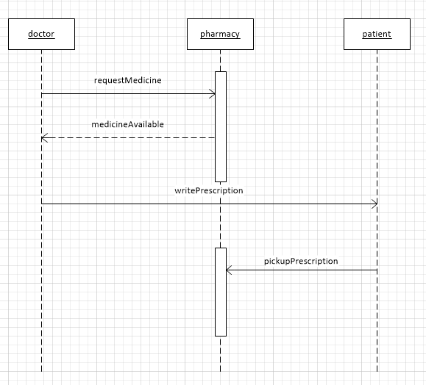

When the patient is done with a visit and needs to make a payment the receptionist checks the database to see if the patient is insured and process any payments made by the patient and update the database.

